Table of Contents
ABSTRACT 4
CHAPTER 1: INTRODUCTION 5
Background: topic 1.1 5
Problem Statement: topic 1.2 5
Objective: topic 1.3 5
Scope of the Project: topic 1.4 6
CHAPTER 2: LITERATURE REVIEW 7
Introduction: topic 2.1 7
Existing Systems: topic 2.2 7
Realted Work: topic 2.3 7
Limitations of Existing Sysytems: topic 2.4 7
Proposed System Advantages: topic 2.5 8
CHAPTER 3: SYSTEM ANALYSIS 9
Introduction: topic 3.1 9
Existing System: topic 3.2 9
Proposed System: topic 3.3 9
Functional Requirements: topic 3.4 9
Non-Functional Requirements: topic 3.5 10
Feasibility Study: topic 3.6 10
CHAPTER 4: TECHNOLOGY STACK 11
Introduction: topic 4.1 11
Frontend Technology: topic 4.2 11
Backend Technology: topic 4.3 11
Database: topic 4.4 11
Authentication: topic 4.5 12
Tools Used: topic 4.6 12
CHAPTER 5: SYSTEM DESIGN 13
Introduction: topic 5.1 13
System Architecture: topic 5.2 13
Database Design: topic 5.3 14
Relationship Between Collections: topic 5.4 14
Data Flow: topic 5.5 15
Design Features: topic 5.6 15
CHAPTER 6: TESTING 16
Introduction: topic 6.1 16
Testing Objectives: topic 6.2 16
Types of Testing: topic 6.3 16
Test Cases: topic 6.4 16
Results of Testing: topic 6.5 17
Limitations of Testing: topic 6.6 17
CHAPTER 7: RESULTS 18
Introduction: topic 7.1 18
System Output: topic 7.2 18
Equipment Management Result: topic 7.3 19
Borrow Result: topic 7.4 20
Database Result: topic 7.5 20
API Response Result: topic 7.6 22
Performance Result: topic 7.7 22
Summary of Results: topic 7.8 23
CHAPTER 8: CHALLENGES FACED 24
Introduction: topic 8.1 24
Technical Challenges: topic 8.2 24
Development Challenges: topic 8.3 24
Solutions Implemented: topic 8.4 24
Learning Outcomes: topic 8.5 25
CHAPTER 9: CONCLUSION AND FUTURE SCOPE 26
Conclusion: topic 9.1 26
Future Scope: topic 9.2 26
REFERENCES 27
APPENDICES 28

ABSTRACT

SportiQ is a mobile-based application developed to digitize and streamline the management of sports equipment in educational institutions such as colleges and universities. Traditional systems rely on manual record-keeping using registers or spreadsheets, which leads to inefficiencies such as lack of real-time availability, difficulty in tracking borrowed items, delayed returns, and lack of accountability.
The proposed system provides a centralized and user-friendly solution where students can view available equipment, borrow items using QR or barcode scanning, track due dates, and monitor penalties for late returns. Administrators can efficiently manage inventory, monitor borrowing activities, and generate reports through a dedicated admin interface.
The application is developed using modern technologies including Flutter for frontend development, Node.js and Express.js for backend services, MongoDB for database management, and Firebase Authentication for secure login. The system ensures real-time data updates, improved transparency, and reduced manual workload.
SportiQ aims to provide a scalable, efficient, and cost-effective solution that enhances resource utilization and improves the overall experience for both students and administrators.

CHAPTER 1: INTRODUCTION

1.1 BACKGROUND
In many educational institutions, sports equipment management is handled using traditional manual methods such as paper registers or spreadsheets. These systems are time-consuming, prone to human errors, and lack real-time tracking capabilities. As a result, it becomes difficult for administrators to maintain accurate records of equipment availability, borrowing, and return status.
With the advancement of mobile and cloud technologies, there is a need to replace these outdated systems with a digital solution that ensures efficiency, transparency, and ease of access. A mobile-based application can provide real-time updates, better tracking, and improved management of resources.

1.2 PROBLEM STATEMENT
The existing manual system for managing sports equipment suffers from several limitations:
- Lack of real-time information about equipment availability
- Difficulty in tracking borrowed and returned items
- Delays in returning equipment due to lack of monitoring
- Manual calculation of penalties leading to errors
- Increased administrative workload
- Risk of equipment loss or misuse
These issues highlight the need for a reliable and automated system that can efficiently manage sports equipment.

1.3 OBJECTIVES
The main objectives of the SportiQ system are:
- To digitize sports equipment management
- To provide real-time tracking of equipment availability
- To simplify the borrowing and return process
- To reduce manual workload and errors
- To ensure accountability through automated tracking and penalties
- To develop a scalable and user-friendly mobile application

1.4 SCOPE OF THE PROJECT
The scope of the project includes the development of a mobile-based system that allows students and administrators to manage sports equipment efficiently. Students can view available items, borrow equipment using QR or barcode scanning, track their usage, and view penalties. Administrators can manage inventory, monitor activities, and generate reports.
The system is designed for use within educational institutions and can be extended in the future to support multiple campuses and advanced analytics features.

CHAPTER 2: LITERATURE REVIEW

2.1 INTRODUCTION
Literature review involves studying existing systems, research papers, and solutions related to the project domain. It helps in understanding the strengths and limitations of current approaches and provides insights for designing an improved system.

2.2 EXISTING SYSTEMS
Several systems have been developed for asset and inventory management; however, most of them are either manual or designed for large-scale enterprises. In educational institutions, sports equipment is commonly managed using paper registers or basic spreadsheets.
These systems suffer from multiple drawbacks such as lack of real-time updates, difficulty in tracking usage, and dependency on manual calculations. Additionally, they do not provide automated features such as penalty calculation or digital tracking of borrowed items.

2.3 RELATED WORK
Some modern inventory management systems use digital platforms and databases to track assets. However, these systems are often complex, costly, and not specifically tailored for educational environments.
Mobile-based solutions with QR or barcode scanning have been used in other domains to improve tracking and automation. These approaches demonstrate the effectiveness of digital systems in reducing manual effort and improving accuracy.

2.4 LIMITATIONS OF EXISTING SYSTEMS
The major limitations observed in existing systems include:
- Lack of real-time data availability
- High dependency on manual record-keeping
- No proper tracking of borrowed and returned items
- Absence of automated penalty calculation
- Limited accessibility and scalability

2.5 PROPOSED SYSTEM ADVANTAGES
The proposed system, SportiQ, overcomes these limitations by providing:
- Real-time equipment tracking
- Automated borrow and return workflow
- QR/barcode-based identification
- Role-based access for students and administrators
- Automated penalty calculation
- Scalable and user-friendly interface

CHAPTER 3: SYSTEM ANALYSIS

3.1 INTRODUCTION
System analysis involves studying the existing system, identifying its limitations, and defining the requirements for the proposed system. It helps in understanding what needs to be improved and how the new system will address existing problems.

3.2 EXISTING SYSTEM
The current system for managing sports equipment in many educational institutions is manual. Records are maintained using paper registers or spreadsheets.
Limitations of the existing system:
- No real-time information about equipment availability
- Difficulty in tracking borrowed and returned items
- High chances of human errors
- Manual calculation of penalties
- Increased administrative workload
- Lack of transparency and accountability

3.3 PROPOSED SYSTEM
The proposed system, SportiQ, is a mobile-based application that automates sports equipment management. It provides a centralized platform for students and administrators to manage equipment efficiently.
Features of the proposed system:
- Real-time tracking of equipment
- QR/barcode-based borrowing system
- Automated penalty calculation
- Role-based access (Student and Admin)
- Easy monitoring and reporting

3.4 FUNCTIONAL REQUIREMENTS
The system should be able to perform the following functions:
Student Module:
- Login using secure authentication
- View available equipment
- Borrow equipment using QR/barcode
- Track borrowed items and due dates
- View penalty details
Admin Module:
- Manage equipment inventory (Add/Update/Delete)
- Monitor borrowing and return activities
- Track overdue items
- Generate reports

3.5 NON-FUNCTIONAL REQUIREMENTS
- Performance: Fast response time and real-time updates
- Security: Secure authentication and role-based access
- Scalability: Ability to handle increasing users and data
- Usability: User-friendly mobile interface
- Reliability: Accurate data handling and minimal errors

3.6 FEASIBILITY STUDY
- Technical Feasibility:
Uses modern and widely supported technologies like Flutter, Node.js, and MongoDB.
- Economic Feasibility:
The system is built using free and open-source tools, making it cost-effective.
- Operational Feasibility:
The system is easy to use and requires minimal training.

CHAPTER 4: TECHNOLOGY STACK

4.1 INTRODUCTION
Technology stack refers to the set of tools, frameworks, and technologies used to develop and deploy the application. The selection of appropriate technologies is important to ensure performance, scalability, and ease of development.

4.2 FRONTEND TECHNOLOGY
Flutter (Dart):
Flutter is used for developing the mobile application. It provides a fast and responsive user interface with a single codebase for multiple platforms. Flutter allows building visually attractive and dynamic applications.

4.3 BACKEND TECHNOLOGY
Node.js:
Node.js is used to build the backend server. It enables fast and scalable server-side development.
Express.js:
Express.js is a lightweight framework used with Node.js to create RESTful APIs and handle server-side logic efficiently.

4.4 DATABASE
MongoDB:
MongoDB is a NoSQL database used to store application data. It provides flexibility in schema design and supports scalable data storage.
Mongoose:
Mongoose is used as an Object Data Modeling (ODM) library to define schemas, validations, and relationships in MongoDB.

4.5 AUTHENTICATION
Firebase Authentication:
Firebase Authentication is used to provide secure login functionality using Google Sign-In. It ensures user identity verification and secure access control.

4.6 TOOLS USED
- Figma : Used for designing wireframes and UI layouts
- Draw.io: Used for creating system architecture and diagrams
- VS Code: Used for coding and development
- Postman: Used for API testing

CHAPTER 5: SYSTEM DESIGN

5.1 INTRODUCTION
System design defines the architecture, components, and data flow of the application. It provides a structured approach to implement the system efficiently. This chapter focuses on the overall architecture and database design of the SportiQ system.

5.2 SYSTEM ARCHITECTURE
The SportiQ system follows a client-server architecture where the mobile application communicates with the backend server through APIs.
Architecture Flow:
Flutter Mobile App → Node.js (Express API) → MongoDB Database → Firebase Authentication
- The Flutter app handles user interaction
- The Node.js backend processes requests and business logic
- MongoDB stores application data
- Firebase Authentication manages user login and security
👉 System Architecture Diagram
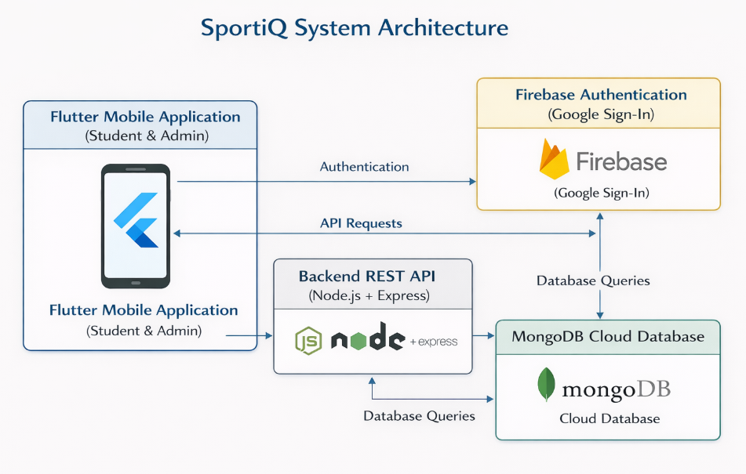

5.3 DATABASE DESIGN
The database is designed using MongoDB with a collection-based structure to ensure flexibility and scalability.
Main Collections:
- User Collection : Stores user details such as name, phone number, college ID, and role (student/admin)
- Equipment Collection : Stores equipment details such as name, type, barcode ID, total quantity, and available quantity
- Rental Collection : Stores borrowing details such as user reference, equipment reference, borrow time, return status, and timestamps

5.4 RELATIONSHIP BETWEEN COLLECTIONS
- User ↔ Rental: One user can have multiple rental records
- Equipment ↔ Rental: One equipment can be borrowed multiple times
Relationships are implemented using ObjectId references to maintain data consistency and enable efficient querying.
👉 (Insert ER Diagram Here)

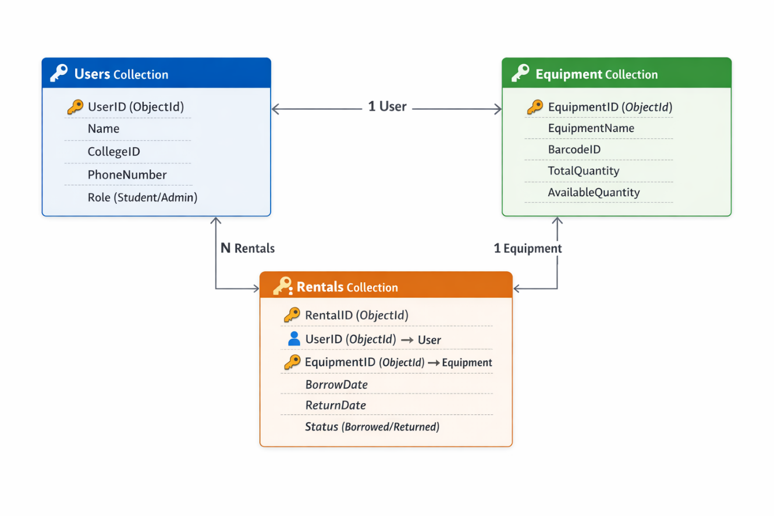

5.5 DATA FLOW (BORROW & RETURN PROCESS)
- Student logs into the system
- Scans QR/barcode of equipment
- Request is sent to backend API
- Database checks equipment availability
- Rental record is created
- Equipment quantity is updated
- On return, status is updated and penalty is calculated (if applicable)
👉 Workflow Diagram
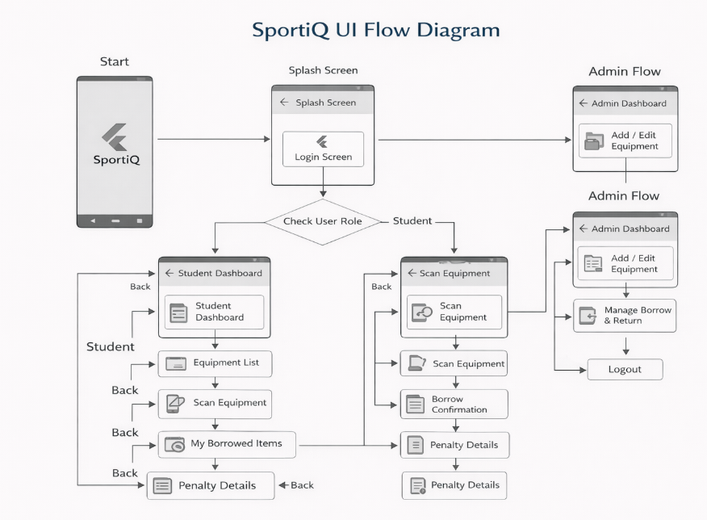

5.6 DESIGN FEATURES
- Scalable and flexible database structure
- Efficient data relationships using references
- Real-time updates of equipment availability
- Separation of concerns between frontend, backend, and database

CHAPTER 6: TESTING

6.1 INTRODUCTION
Testing is an essential phase in software development that ensures the system works correctly and meets the specified requirements. It helps in identifying errors, validating functionality, and improving the overall quality of the system.

6.2 TESTING OBJECTIVES
The main objectives of testing in the SportiQ system are:
- To verify correct implementation of all modules
- To ensure accurate data handling and storage
- To validate the borrow and return workflow
- To check system reliability and performance
- To detect and fix errors

6.3 TYPES OF TESTING
6.3.1 UNIT TESTING
Individual components such as database models and API endpoints were tested independently to ensure correctness.
6.3.2 INTEGRATION TESTING
The interaction between frontend, backend, and database was tested to ensure smooth data flow.
6.3.3 SYSTEM TESTING
The complete system was tested as a whole to verify overall functionality.

6.4 TEST CASES
Test Case ID | Description | Expected Result | Actual Result
TC-01 | User Login | User successfully logs in | Passed
TC-02 | View Equipment | Equipment list displayed | Passed
TC-03 | Borrow Equipment | Rental record created | Passed
TC-04 | Return Equipment | Status updated correctly | Passed
TC-05 | Penalty Calculation | Correct penalty shown | Passed

6.5 RESULTS OF TESTING
- All major functionalities were tested successfully
- Borrow and return workflow worked correctly
- Data consistency was maintained across collections
- Minor issues were identified and resolved

6.6 LIMITATIONS OF TESTING
- Limited testing under high user load
- Some edge cases may require further validation

CHAPTER 7: RESULTS

7.1 INTRODUCTION
This chapter presents the outcomes obtained after implementing and testing the SportiQ system. The results demonstrate how effectively the system meets the project objectives and solves the identified problems.

7.2 SYSTEM OUTPUT
The SportiQ application successfully provides a digital platform for managing sports equipment. The system allows users to perform operations such as login, viewing equipment, borrowing items, returning items, and checking penalties.
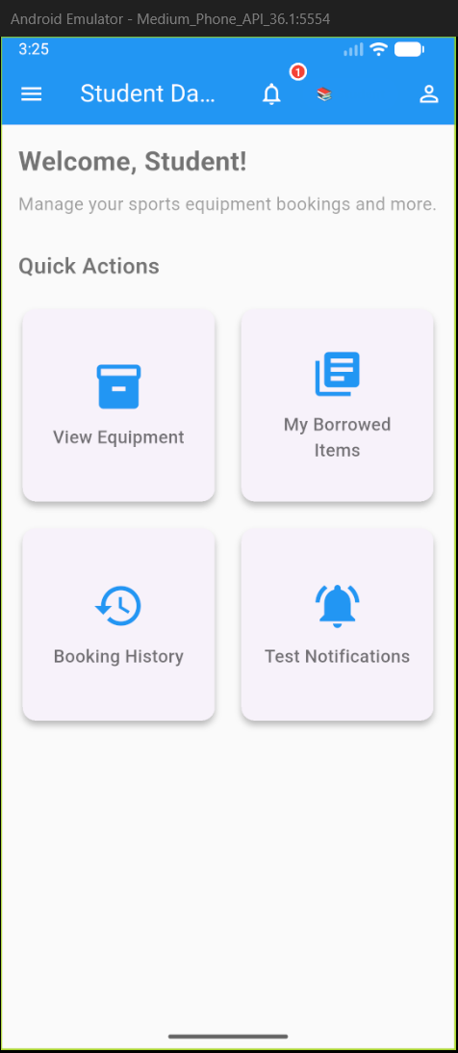
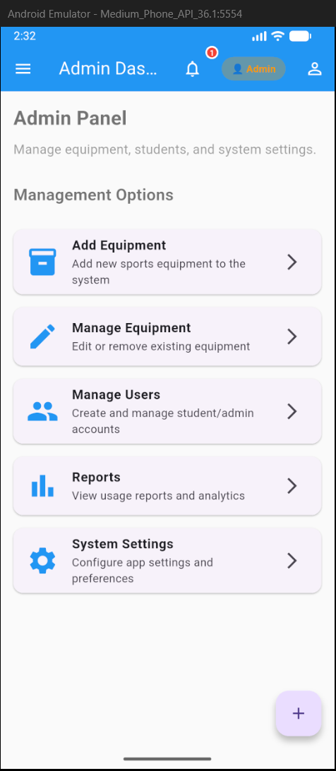
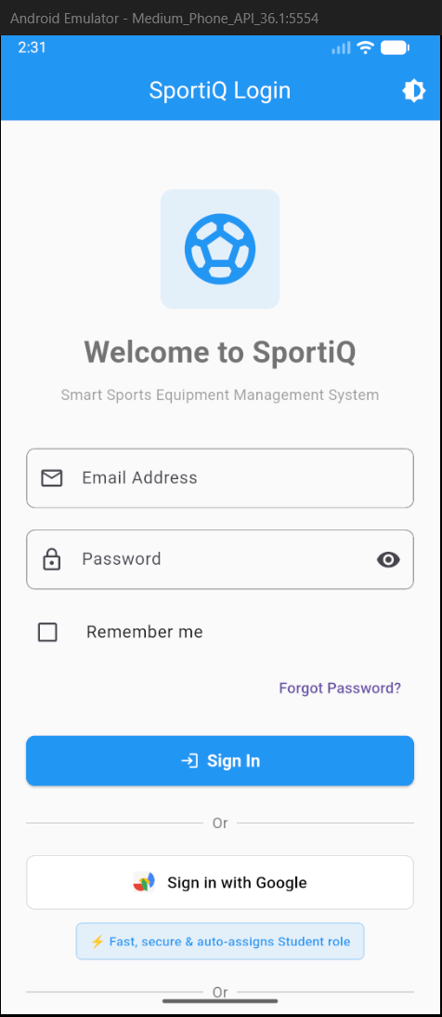
Fig 7.1 System Dashboard Interface

7.3 EQUIPMENT MANAGEMENT RESULT
The admin module allows efficient management of equipment inventory. Administrators can add, update, and remove equipment, and the system reflects changes in real-time.
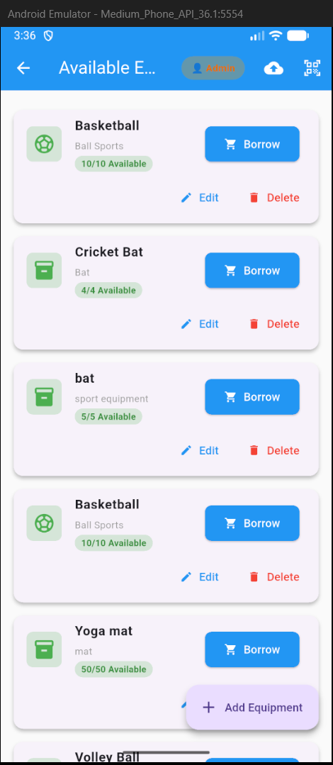
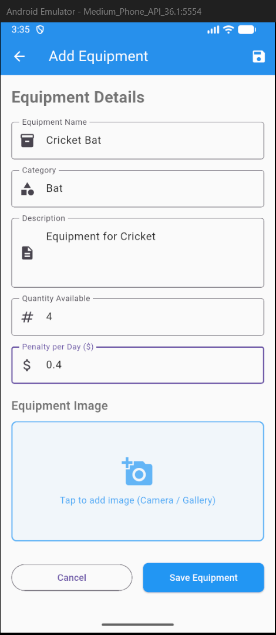

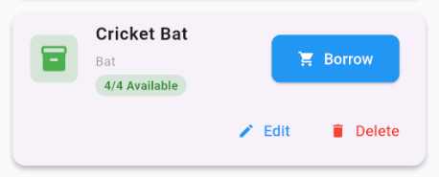
Fig 7.2 Equipment Management Module

7.4 BORROW RESULT

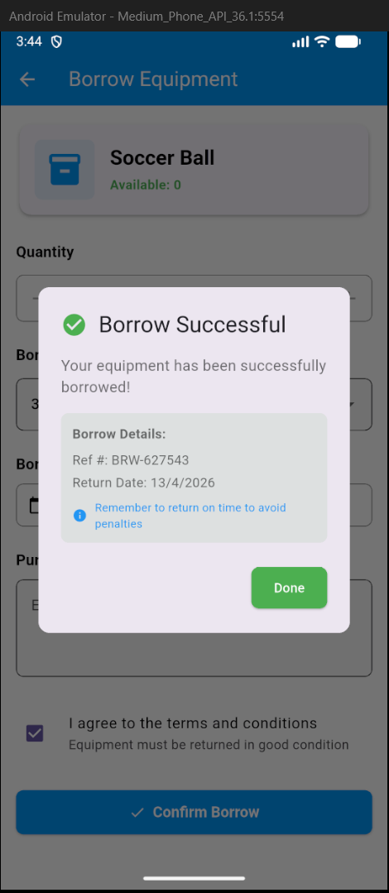
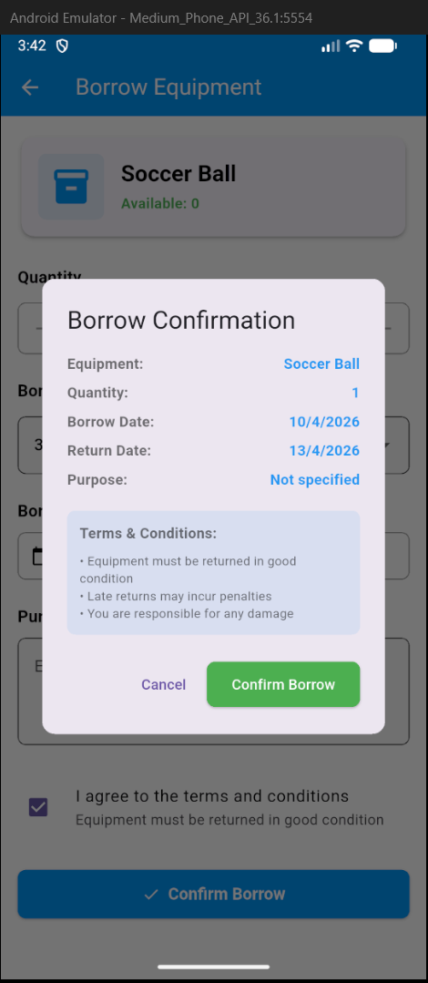
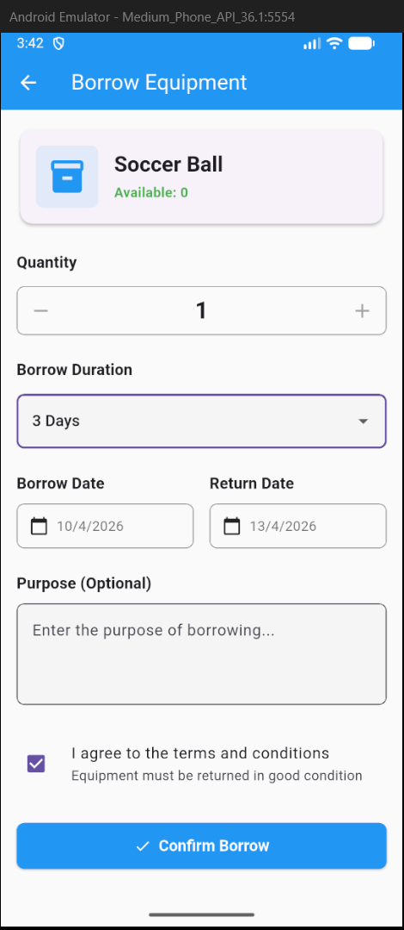
The borrowing process works smoothly with proper updates in the database. The system maintains accurate records of each transaction.
Fig 7.3 Borrow Workflow

7.5 DATABASE RESULT
The MongoDB database successfully stores and manages all records related to users, equipment, and rentals. Relationships between collections are maintained using ObjectId references.
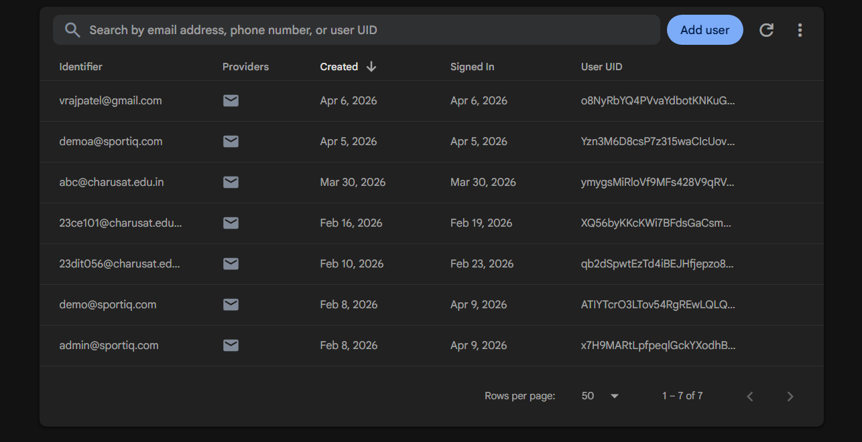
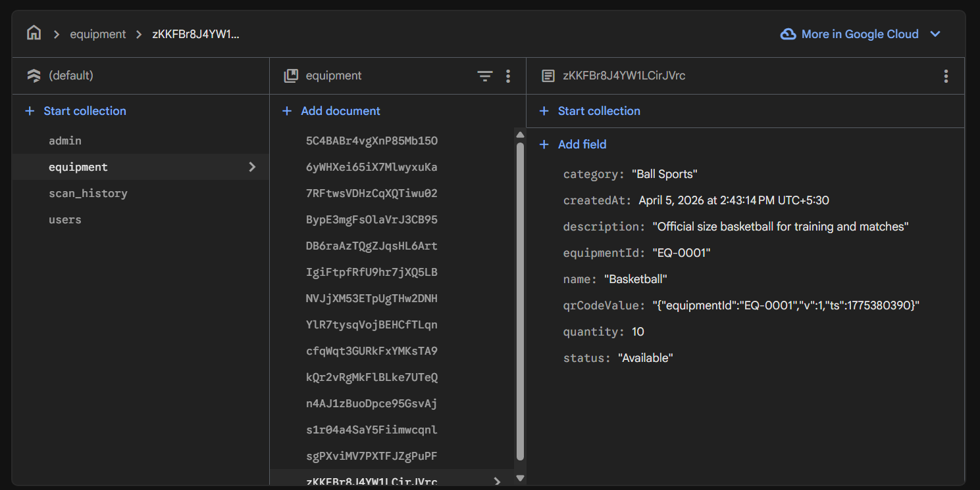
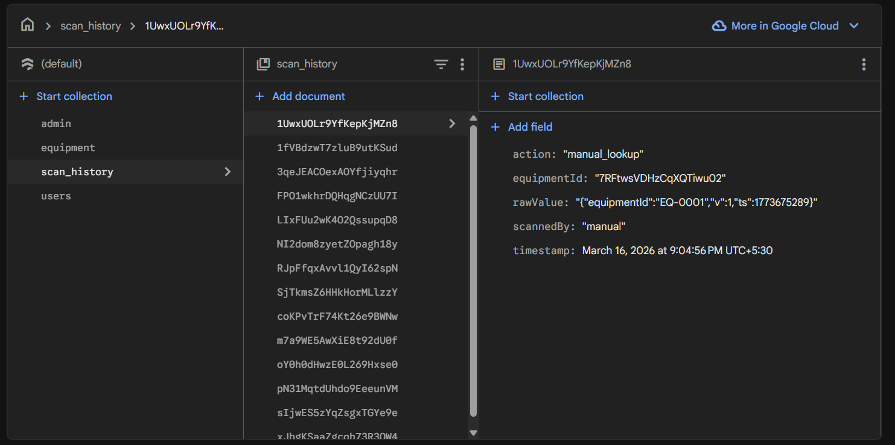
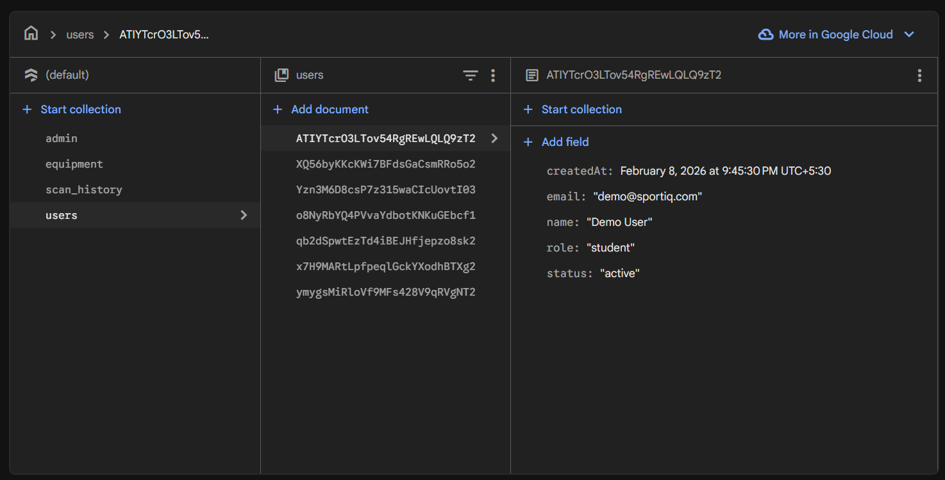
Fig 7.4 Database Records in MongoDB

7.6 API RESPONSE RESULT
The backend APIs function correctly and provide accurate responses for all operations such as fetching equipment data, creating rental records, and updating status.
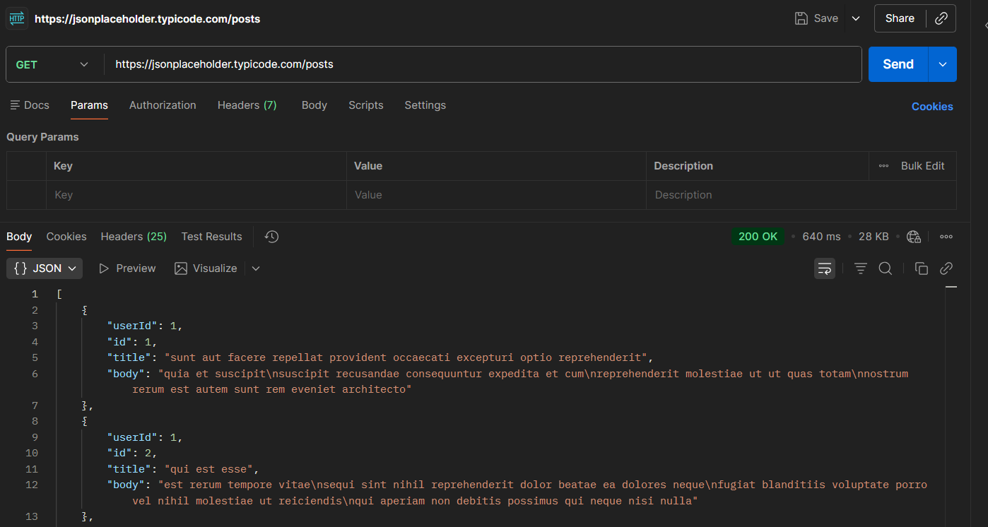
Fig 7.5 API Response Verification

7.7 PERFORMANCE RESULT
- The system provides fast response time
- Real-time updates are reflected accurately
- Data consistency is maintained across all modules

7.8 SUMMARY OF RESULTS
The SportiQ system successfully achieves its objectives by providing a reliable, efficient, and user-friendly solution for sports equipment management. The integration of frontend, backend, and database ensures smooth operation and improved overall performance.

CHAPTER 8: CHALLENGES FACED

8.1 INTRODUCTION
During the development of the SportiQ system, several challenges were encountered at different stages of the project. These challenges helped in gaining practical knowledge and improving problem-solving skills.

8.2 TECHNICAL CHALLENGES
8.2.1 DATABASE DESIGN COMPLEXITY
Designing a scalable and efficient MongoDB schema was challenging. Deciding between embedding and referencing required careful consideration to maintain data consistency and performance.

8.2.2 DATA CONSISTENCY
Ensuring synchronization between equipment availability and rental records was difficult. Proper updates were required during borrow and return operations to avoid inconsistencies.

8.2.3 API INTEGRATION
Integrating frontend with backend APIs required handling multiple requests and ensuring correct data flow. Debugging API responses and handling errors was challenging.

8.2.4 AUTHENTICATION HANDLING
Implementing secure authentication using Firebase and managing user roles (student/admin) required proper validation and backend support.

8.3 DEVELOPMENT CHALLENGES
- Managing coordination between frontend, backend, and database modules
- Debugging errors during development
- Handling real-time updates in the system

8.4 SOLUTIONS IMPLEMENTED
- Used ObjectId references to maintain proper relationships
- Applied validation rules to ensure correct data entry
- Tested APIs using Postman to debug issues
- Ensured proper update logic for borrow and return operations

8.5 LEARNING OUTCOMES
- Improved understanding of database design and relationships
- Gained experience in backend API development
- Learned debugging and testing techniques
- Understood real-world system development challenges

CHAPTER 9: CONCLUSION AND FUTURE SCOPE

9.1 CONCLUSION
The SportiQ system successfully addresses the challenges associated with manual sports equipment management in educational institutions. By introducing a digital platform, the system improves efficiency, transparency, and accuracy in managing equipment.
The application provides real-time tracking of equipment availability, simplifies the borrowing and return process, and ensures accountability through automated monitoring and penalty calculation. The integration of Flutter, Node.js, MongoDB, and Firebase Authentication results in a robust and scalable system.
Overall, the project demonstrates a complete software development lifecycle, from problem identification and requirement analysis to system design, implementation, and testing. The system meets all the defined objectives and provides a practical solution for real-world use.

9.2 FUTURE SCOPE
The SportiQ system can be further enhanced with additional features such as:
- Push notifications for due dates and reminders
- Advanced analytics dashboard for usage trends
- Online penalty payment integration
- Feedback and rating system for equipment
- Multi-campus support for larger institutions
- Integration with IoT devices for automated tracking

REFERENCES

[1] MongoDB, “Data Model Design,” MongoDB Documentation.
Available: https://www.mongodb.com/docs/manual/core/data-model-design/
(Accessed: Dec. 18, 2025)

[2] Mongoose, “Mongoose Documentation,”
Available: https://mongoosejs.com/docs/
(Accessed: Jan. 04, 2026)

[3] Firebase, “Firebase Authentication,” Google Firebase.
Available: https://firebase.google.com/docs/auth
(Accessed: Jan. 16, 2026)

[4] Node.js, “Node.js Documentation,”
Available: https://nodejs.org/en/docs
(Accessed: Jan. 08, 2026)

[5] Express.js, “Express Web Framework,”
Available: https://expressjs.com/
(Accessed: Jan. 10, 2026)

[6] Flutter, “Flutter Documentation,”
Available: https://docs.flutter.dev/
(Accessed: Feb. 05, 2026)

[7] Postman, “Postman API Platform,”
Available: https://www.postman.com/
(Accessed: Mar. 10, 2026)

[8] R. S. Pressman, Software Engineering: A Practitioner’s Approach, 8th ed. New York, USA: McGraw-Hill, 2015.

APPENDICES

A.1 INTRODUCTION
Appendices include additional supporting materials that are not part of the main report but help in understanding the implementation and functionality of the system.

A.2 SAMPLE API REQUESTS AND RESPONSES
Example:
- GET /equipment → Fetch all equipment
- POST /borrow → Create rental record
- PUT /return → Update return status

A.3 DATABASE COLLECTION STRUCTURE
Collections used:
- User
- Equipment
- Rental
Include:
- Sample document structure
- Fields and relationships

A.4 USER INTERFACE
- Login Screen
- Dashboard
- Equipment List
- Borrow Screen
- Return Screen

A.5 ADDITIONAL DETAILS
- Extra configurations
- Error handling logs
- Testing outputs

